Introduction to VHDL: Project Report
Design of a Robot

Name: Anuja Kumar
SID: 800706682
e-mail: akumar13@uncc.edu

OBJECTIVE
To design a robot which loads and unloads an object onto different stations depending on the request. The sensors connected to the robot will sense the request and initiate the correct sequence of operation.

SPECIFICATIONS AND ASSUMPTIONS
- The robot has 5 degree of movement –
- Base movement (A)
- Shoulder movement (B)
- Arm movement (C)
- Wrist Movement (D)
- Claw movement (E)
- There are five stations L, S1, S2, S3 and S4 that can load and unload the robot arm and have priorities from highest to lowest respectively.
- The loading operation at any station for an unloading operation requested by a lower priority station can be interrupted by an unloading operation request by a higher priority station.
- Unloading operations cannot be interrupted.

THEORY OF OPERATION

The setup contains five stations L, S1, S2, S3 and S4 that can load and unload the robot arm and have priorities from highest to lowest respectively. The Sensors input in the Robot represents the requesting stations to unload the data. The Source input tells the arm which station to load from.
There are 5 degrees of freedom to the robot and each has two possible orientations. The control signals to the motor define the movement of these parts. Each of the joints performs 3 actions (Except the claw E) - Stay, Obtuse angle turn and acute angle turn. So two bits are required to represent each of the movement.

A | B | C | D | E
00 | 00 | 00 | 00 | 0
01 | 01 | 01 | 01 | 1
10 | 10 | 10 | 10

These 9 bits are represented by the output variable Zout that is set in order to bring about desired movements of the arm.

Each loading and unloading operation involves setting the output variable Zout to specific values in order to move the arm to and from the station. After every load and unload operation, the arm comes back to its central position. A loading operation taking place as a consequence of an unload request by a station with lower priority can be interrupted by an unload request from station of higher priority. The occurrence of a valid interrupt is checked after loading the object, but before going back to central position. If an interrupt has occurred, the arm unloads the object at the same station and goes back to central position empty. It then services the interrupt.

VHDL CODE BLOCK DIAGRAM

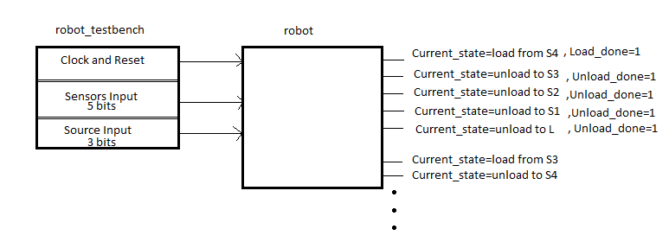
DESIGN

As per the requirements, the system is designed to have 5 loading and unloading stations L, S1, S2, S3, S4 and S5 with priorities high to low respectively. There are two inputs which decide the flow Sensors and Source. The Sensors input decides the Destination where object has to be unloaded and Source decides the station from where object is to be loaded. Only Unloading requests with Sensors and Source are generated by any station. Any unloading request can only interrupt Loading operations taking place as a result of unload requests generated by stations of lower priority. There are flags indicating current operation, Current Load/ Unload complete status.etc for debugging purposes.

Sensors Table and Source Table:

SENSORS | UNLOAD STATION  and DEST | SOURCE | LOAD STATION
00001 | L | 000 | L
00010 | S1 | 001 | S1
00100 | S2 | 010 | S2
01000 | S3 | 011 | S3
10000 | S4 | 100 | S4

FLOW CHART: START

STOP Rising edge
of clk?

Y

N
reset=1? Current_state=
default

Y
Check Sensors i/p
and decide dest station
Check Source i/p
and decide load station

Load object from station

Interrupt from N
Station of higher
Prio?

Y

Unload object at Source station Load_done=1
Load_done=0

Go back to default state

N
Load_done = 1?

Y

Unload object at Destination

STATE MACHINE:

A very simplistic form of the state machine is shown here. There would actually be five load states and 5 unload states. However, this gives the basic idea of the state machine.
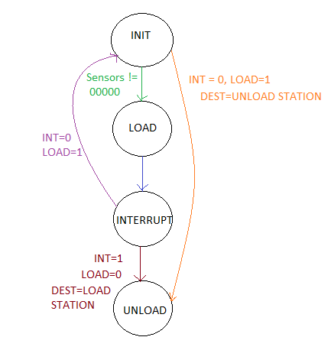

VERIFICATION

The files robot.vhd and robo_top.vhd should be referred for detailed steps.
The testbench is written so that the following cases are tested:

- Loading from S4 and Unloading at S3,S2,S1 and L
- Loading from S3 and Unloading at S4,S2,S1 and L
- Loading from S2 and Unloading at S4,S3,S1 and L
- Loading from S1 and Unloading at S4,S3,S2 and L
- Loading from L and Unloading at S4,S3,S2 and S1
- In order to test interrupts, one case where a Load from station S3-Unload at S4 is interrupted by a Load from station S2-Unload at S3
- Reset

SIMULATION RESULTS

The following figures will verify some cases mentioned above as examples proving correct working of code.

- Load at S4-Unload at S3

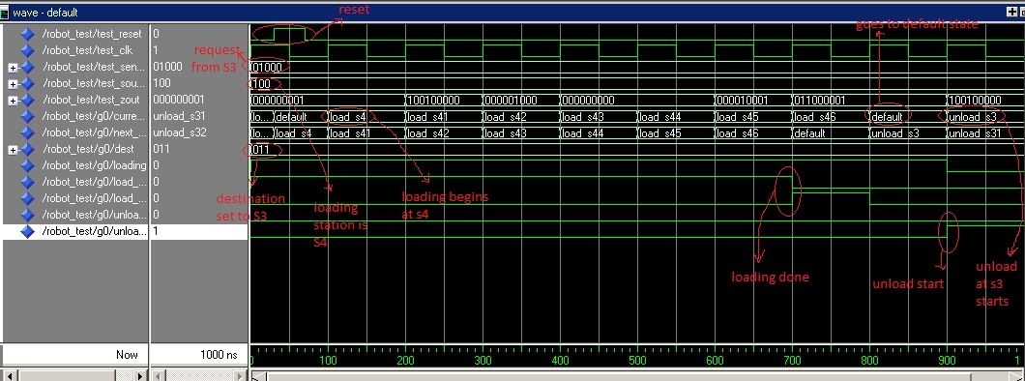

- Load at S4-Unload at S1

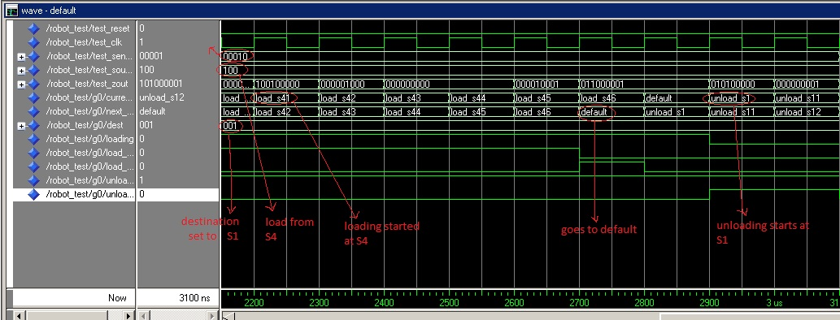

- Load at S3-Unload at S4
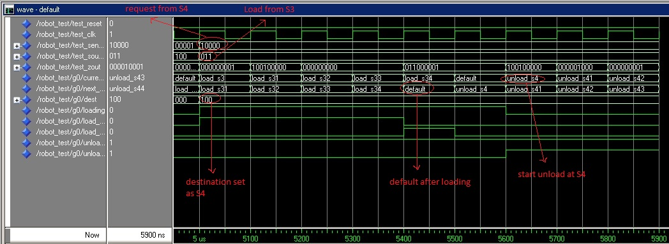

- Load at S3-Unload at S2

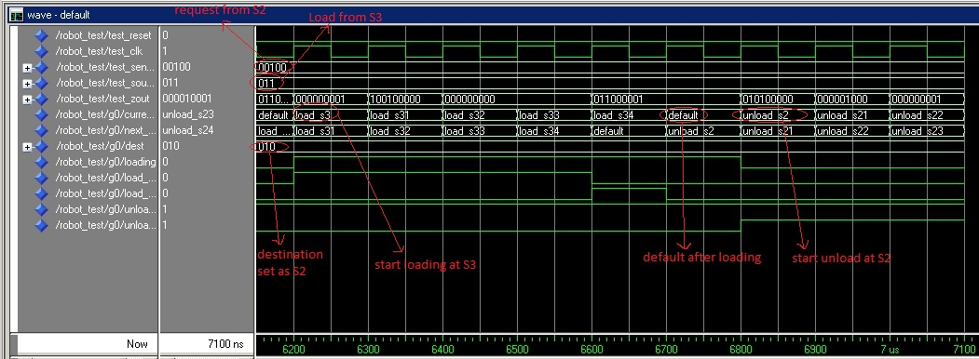

- Load at S2-Unload at S4

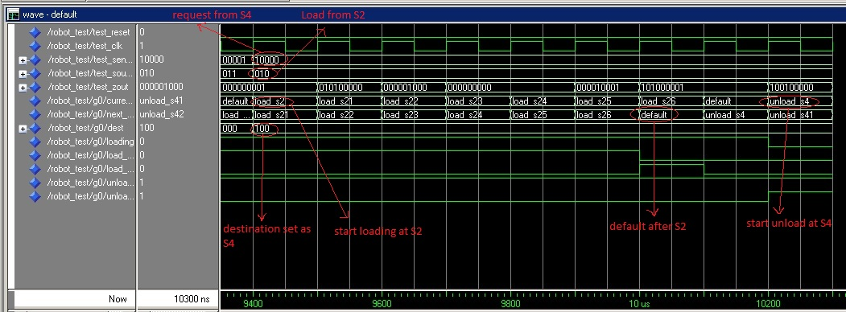

- Load at S2-Unload at S1

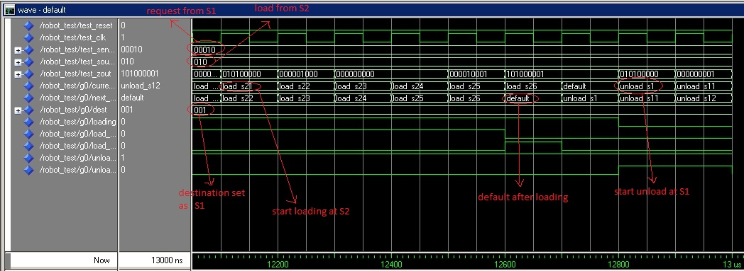

- Load at S1-Unload at S2

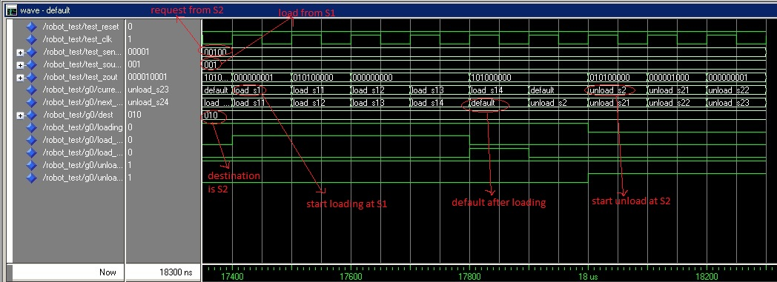

- Load at S1-Unload at S4

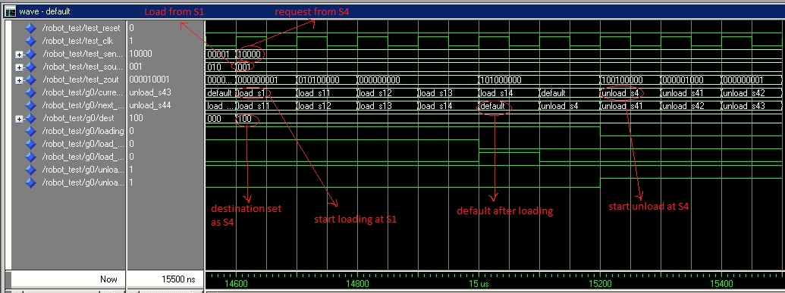

- Load at L-Unload at S3

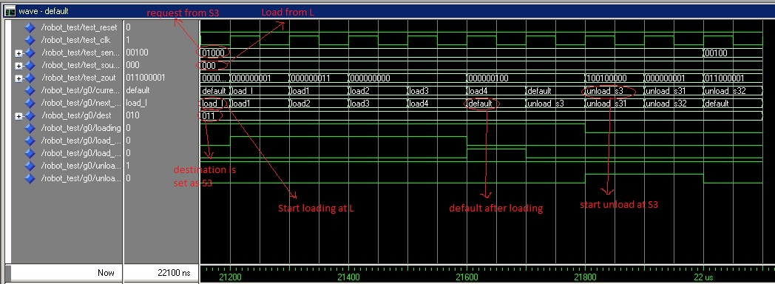

- Load at L-Unload at S1

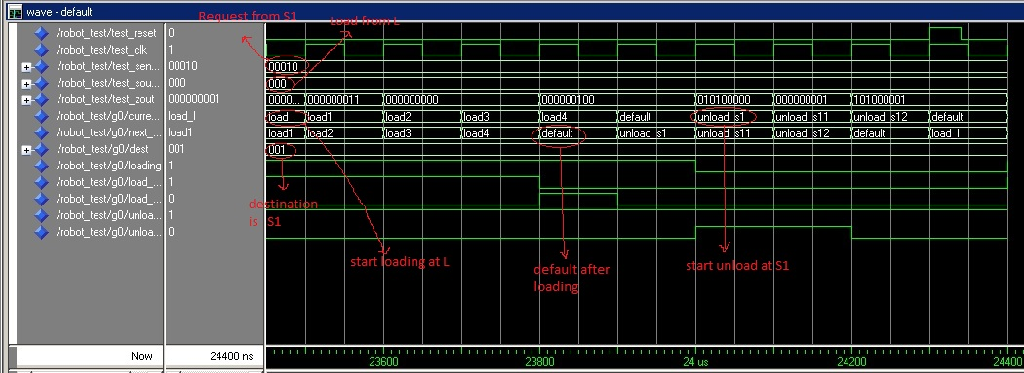

- Interrupt

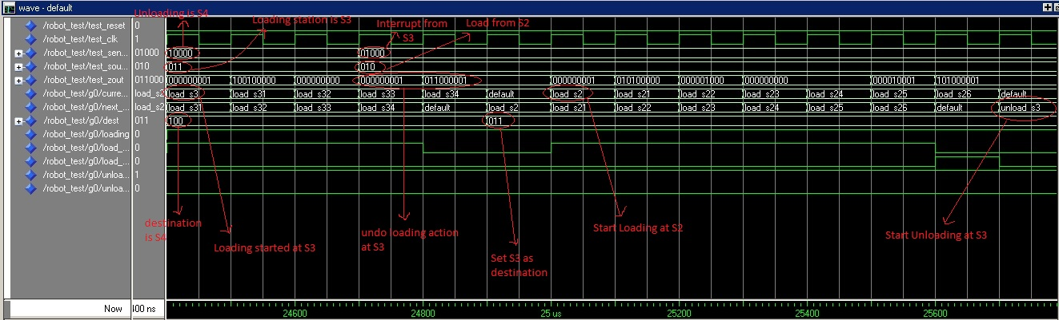

CODE

Source code:
robot.vhd:

library ieee;
use ieee.std_logic_1164.all;
use ieee.std_logic_arith.all;

ENTITY robot IS
PORT (
reset : IN BIT; -- reset=1 gets statemachine to default state
clk : IN BIT;
Sensors : IN BIT_VECTOR(4 downto 0); -- Sensor bit is high when a station genrates request
Source : IN BIT_VECTOR(2 downto 0); -- Source is the station from which to load
Zout : OUT BIT_VECTOR(8 downto 0); -- Zout are the output bits to move arm
stateout:OUT BIT_VECTOR(3 downto 0):="0000"); -- It gives current state
END robot;

ARCHITECTURE behave of robot is
type state is (default,load_L,load1,load2,load3,load4,load_s1,load_s11,load_s12,load_S13,load_s14,load_s2,load_s21,load_s22,load_s23,load_s24,load_s25,load_s26,load_s3,load_s31,load_s32,load_s33,load_s34,load_s4,load_s41,load_s42,load_s43,load_s44,load_s45,load_s46,unload_L,unload_s1,unload_s11,unload_s12,unload_s2,unload_s21,unload_s22,unload_s23,unload_s24,unload_s3,unload_s31,unload_s32,unload_s4,unload_s41,unload_s42,unload_s43,unload_s44);
signal current_state,next_state :state:= default;
signal loading,load_start,load_done,unload_done:bit:= '0';
signal unload_start :bit:= '0';
signal Dest:BIT_VECTOR(2 downto 0):="000";
BEGIN

control_process:PROCESS(Sensors,Source,current_state)
variable interrupt:BIT;
BEGIN

CASE current_state is
when default => stateout<="0000";

if(Sensors="00001")then
Dest<="000"; --request from L
elsif(Sensors="00010")then
Dest<="001"; --request from S1
elsif(Sensors="00100")then
Dest <="010"; --request from S2
elsif(Sensors="01000")then
Dest <= "011"; --request from S3
elsif(Sensors="10000")then
Dest <= "100"; --request from S4
end if;

if(Source="000" and load_done='0' )then
next_state <= load_L; -- Load from L

elsif(Source="001" and load_done='0' )then
next_state <= load_s1; -- Load from S1

elsif(Source="010" and load_done='0' )then
next_state <= load_s2; -- Load from S2

elsif(Source="011" and load_done='0')then
next_state <= load_s3; --Load from S3

elsif(Source="100" and load_done='0' )then
next_state <= load_s4; --Load from S4
end if;

if(Dest="000" and load_done='1' and interrupt='0')then
load_done<='0'; --Unload to L
next_state<=unload_L;

elsif(Dest="001" and load_done='1' and interrupt='0')then
load_done<='0'; --Unload to S1
next_state<=unload_s1;

elsif(Dest="010" and load_done='1' and interrupt='0')then
load_done<='0'; --Unload to S2
next_state<=unload_s2;

elsif(Dest="011" and load_done='1' and interrupt='0')then
load_done<='0'; -- Unload to S3
next_state<=unload_s3;

elsif(Dest="100" and load_done='1' and interrupt='0')then
load_done<='0'; -- Unload to S4
next_state<=unload_s4;
end if;

--load L1
when Load_L => loading<='1';
stateout<="0001";
load_start <= '1';
zout <= "000000001";
next_state <= load1;
when load1 =>
zout <= "000000011";
next_state <= load2;
when load2 =>
zout <= "000000000";
next_state <= load3;

when load3 =>

if(Sensors="00001" and (Dest="001" or Dest="010" or Dest="011" or Dest="100"))then
interrupt:='1';
elsif(Sensors="00010" and (Dest="010" or Dest="011" or Dest="100"))then
interrupt:='1';
elsif(Sensors="00100" and (Dest="011" or Dest="100"))then
interrupt:='1';
elsif(Sensors="01000" and (Dest="100"))then
interrupt:='1';
end if;

if(interrupt='1')then -- if interrupted by higher prio station, release claw
zout<="000000001";
load_done<='0';

end if;
next_state<=load4;
when load4=> --retrace steps to default position
zout <= "000000100";
load_start <= '0';
if(interrupt='1')then
load_done<='0';
interrupt:='0';
else
load_done<='1';
end if;

next_state <= default;

--load s1
when load_s1 => loading <='1';
stateout<="0010";
zout <= "000000001";
next_state <= load_s11;
load_start <='1';

when load_s11 =>
zout <= "010100000";
next_state <= load_s12;

when load_s12 =>
zout <= "000000000";
next_state <= load_s13;

when load_s13 =>

if(Sensors="00001" and (Dest="001" or Dest="010" or Dest="011" or Dest="100"))then
interrupt:='1';
elsif(Sensors="00010" and (Dest="010" or Dest="011" or Dest="100"))then
interrupt:='1';
elsif(Sensors="00100" and (Dest="011" or Dest="100"))then
interrupt:='1';
elsif(Sensors="01000" and (Dest="100"))then
interrupt:='1';
end if;

if(interrupt='1')then -- if interrupted by higher prio station, release claw
zout<="000000001";
load_done<='0';

end if;
next_state<=load_s14;
when load_s14=>
zout <= "101000000";
load_start <= '0';
if(interrupt='1')then
load_done<='0';
interrupt:='0';
else
load_done<='1';
end if;
next_state <= default;

--load s2
when load_s2 => loading <='1';
stateout<="0011";
load_start <='1';
zout <= "000000001";
next_state <= load_s21;

when load_s21 =>
zout <= "010100000";
next_state <= load_s22;

when load_s22 =>
zout <= "000001000";
next_state <= load_s23;

when load_s23 =>

zout <= "000000000";
next_state <= load_s24;

when load_s24 =>

if(Sensors="00001" and (Dest="001" or Dest="010" or Dest="011" or Dest="100"))then
interrupt:='1';
elsif(Sensors="00010" and (Dest="010" or Dest="011" or Dest="100"))then
interrupt:='1';
elsif(Sensors="00100" and (Dest="011" or Dest="100"))then
interrupt:='1';
elsif(Sensors="01000" and (Dest="100"))then
interrupt:='1';
end if;

if(interrupt='1')then -- if interrupted by higher prio station, release claw
zout<="000000001";
load_done<='0';

end if;
next_state<=load_s25;
when load_s25=>
zout <= "000010001";
next_state <= load_s26;

when load_s26 =>
zout <= "101000001";
load_start <= '0';
if(interrupt='1')then
load_done<='0';
interrupt:='0';
else
load_done<='1';
end if;

next_state <= default;

--load s3
when load_s3 => loading <='1';
stateout<="0100";
load_start <='1';
zout <= "000000001";
next_state <= load_s31;

when load_s31 =>
zout <= "100100000";
next_state <= load_s32;

when load_s32 =>
zout <= "000000000";
next_state <= load_s33;

when load_s33 =>

if(Sensors="00001" and (Dest="001" or Dest="010" or Dest="011" or Dest="100"))then
interrupt:='1';
elsif(Sensors="00010" and (Dest="010" or Dest="011" or Dest="100"))then
interrupt:='1';
elsif(Sensors="00100" and (Dest="011" or Dest="100"))then
interrupt:='1';
elsif(Sensors="01000" and (Dest="100"))then
interrupt:='1';
end if;

if(interrupt='1')then -- if interrupted by higher prio station, release claw
zout<="000000001";
load_done<='0';

end if;
next_state<=load_s34;
when load_s34=>
zout <= "011000001";
load_start <= '0';
if(interrupt='1')then
load_done<='0';
interrupt:='0';
else
load_done<='1';
end if;

next_state <= default;

--load s4
when load_s4 => loading <='1';
stateout<="0101";
load_start <= '1';
zout <= "000000001";
next_state <= load_s41;

when load_s41 =>
zout <= "100100000";
next_state <= load_s42;

when load_s42 =>
zout <= "000001000";
next_state <= load_s43;

when load_s43 =>
zout <= "000000000";
next_state <= load_s44;

when load_s44 =>

if(Sensors="00001" and (Dest="001" or Dest="010" or Dest="011" or Dest="100"))then
interrupt:='1';
elsif(Sensors="00010" and (Dest="010" or Dest="011" or Dest="100"))then
interrupt:='1';
elsif(Sensors="00100" and (Dest="011" or Dest="100"))then
interrupt:='1';
elsif(Sensors="01000" and (Dest="100"))then
interrupt:='1';
end if;

if(interrupt='1')then -- if interrupted by higher prio station, release claw
zout<="000000001";
load_done<='0';

end if;
next_state<=load_s45;
when load_s45=>
zout <= "000010001";
next_state <= load_s46;

when load_s46 =>
zout <= "011000001";
load_start <= '0';
if(interrupt='1')then
load_done<='0';
interrupt:='0';
else
load_done<='1';
end if;

next_state <= default;

--unload at L

when unload_L => loading<='0';
stateout<="0110";

zout <= "000000101";
next_state <= default;

--unload at s1
when unload_s1 => loading <='0';
stateout<="0111";
unload_start <='1';
zout <= "010100000";
next_state <= unload_s11;

when unload_s11 =>
zout <= "000000001";
next_state <= unload_s12;

when unload_s12 =>
zout <= "101000001";
unload_start <='0';
unload_done <= '1';
next_state <= default;

--unload at S2
when unload_s2 => loading <='0';
stateout<="1000";
unload_start <='1';
zout <= "010100000";
next_state <= unload_s21;

when unload_s21 =>
zout <= "000001000";
next_state <= unload_s22;

when unload_s22 =>
zout <= "000000001";
next_state <= unload_s23;

when unload_s23 =>
zout <= "000010001";
next_state <= unload_s24;

when unload_s24 =>
zout <= "101000001";
unload_done <='1';
unload_start <= '0';
next_state <= default;

--Unload at S3
when unload_s3 => loading <='0';
stateout<="1001";
unload_start <='1';
zout <= "100100000";
next_state <= unload_s31;

when unload_s31 =>
zout <= "000000001";
next_state <= unload_s32;

when unload_s32 =>
zout <= "011000001";
unload_done <='1';
unload_start <='0';
next_state <= default;

--unload at S4
when unload_s4 => loading <='0';
stateout<="1010";
unload_start <= '1';
zout <= "100100000";
next_state <= unload_s41;

when unload_s41 =>
zout <= "000001000";
next_state <= unload_s42;

when unload_s42 =>
zout <= "000000001";
next_state <= unload_s43;

when unload_s43 =>
zout <= "000010001";
next_state <= unload_s44;

when unload_s44 =>
zout <= "011000001";
unload_done <= '1';
unload_start <= '0';
next_state <= default;
end case;

end process;

state_change : process(clk, reset)
begin
if (reset ='1') then
current_state <= default;
elsif(clk'event and clk ='1') then

current_state <= next_state;
end if;
end process state_change;
end behave;

Test-Bench Code

library IEEE;
use IEEE.STD_LOGIC_1164.ALL;
use IEEE.STD_LOGIC_ARITH.ALL;

ENTITY robot_test IS
End robot_test;

Architecture robo_testb of robot_test is
COMPONENT c1 PORT (
reset : IN BIT;
clk : IN BIT;
Sensors : IN BIT_VECTOR(4 downto 0);
Source : IN BIT_VECTOR(2 downto 0);
Zout : OUT BIT_VECTOR(8 downto 0);
stateout:OUT BIT_VECTOR(3 downto 0));
END COMPONENT;

FOR g0 : c1 USE ENTITY WORK. robot(behave);
signal test_reset :BIT:='0';
signal test_clk : BIT:='0';
signal test_Sensors : BIT_VECTOR(4 downto 0);
signal test_Source : BIT_VECTOR(2 downto 0);
signal test_Zout : BIT_VECTOR(8 downto 0);
signal test_stateout: BIT_VECTOR(3 downto 0);
begin
clock_process : PROCESS is
BEGIN
test_clk <= NOT(test_clk);
wait for 50 ns;
END PROCESS;

g0 : c1 PORT MAP (test_reset,test_clk,test_Sensors,test_Source,test_Zout,test_stateout);

t1:test_reset<=
'0',
'1' after 30ns,
'0' after 70 ns,
'1' after 4900 ns,
'0' after 4940 ns,
'1' after 9300 ns,
'0' after 9340 ns,
'1' after 14500 ns,
'0' after 14540 ns,
'1' after 19300 ns,
'0' after 19340 ns,
'1' after 24300 ns,
'0' after 24340 ns;

t2: test_Source<=
"100", --Load from S4
"011" after 5000 ns, --Load from S3
"010" after 9400 ns, --Load from S2
"001" after 14600 ns, --Load from S1
"000" after 19400 ns, --Load from L
"011" after 24400 ns,
"010" after 24700 ns;

t3:test_Sensors<=
"01000", --Unload to S3
"00100" after 1300 ns, --Unload to S2
"00010" after 2700 ns, --Unload to S1
"00001" after 3900 ns, --Unload to L

"10000" after 5000 ns, --Unload to S4
"00100" after 6000 ns, --Unload to S2
"00010" after 7300 ns, --Unload to S1
"00001" after 8300 ns, --Unload to L

"10000" after 9400 ns, --Unload to S4
"01000" after 10400 ns, --Unload to S3
"00010" after 11700 ns, --Unload to S1
"00001" after 13300 ns, --Unload to L

"10000" after 14600 ns, --Unload to S4
"01000" after 15700 ns, --Unload to S3
"00100" after 17000 ns, --Unload to S2
"00001" after 18300 ns, --Unload to L

"10000" after 19400 ns, --Unload to S4
"01000" after 20700 ns, --Unload to S3
"00100" after 22000 ns, --Unload to S2
"00010" after 23300 ns, --Unload to S1

"10000" after 24400 ns, --Unload to S4 INTERRUPT
"01000" after 24700 ns; --Unload to S3

end robo_testb;

