Inverter

Write the vhdl for the circuit. Here we consider the example of an inverter

inverter.vhd

library IEEE; use IEEE.std_logic_1164.all;
entity inverter is port (input : in std_logic; output : out std_logic); end inverter;
architecture structural of inverter is begin output <= not (input); end structural;
Run it through design vision and we can save a .v(verilog) file
inverter.v
module inverter ( \input , \output ); input \input ; output \output ;
INV_X1 U2 ( .A(\input ), .ZN(\output ) );
Endmodule

Add the design(.v netlist) in encounter, Place and Route it and do RC Extraction where we get a .spef file.
A typical SPEF file will have 4 main sections
– a header section,
– a name map section,
– a top level port section and
– the main parasitic description section.
Generally, SPEF keywords are preceded with a *. For example, *R_UNIT, *NAME_MAP and *D_NET.
inverter.spef

*SPEF "IEEE 1481-1998"
*DESIGN "inverter"
*DATE "Sat Mar 19 16:00:57 2011"
*VENDOR "Silicon Perspective, A Cadence Company"
*PROGRAM "Encounter"
*VERSION "10.10-s002_1"
*DESIGN_FLOW "PIN_CAP NONE" "NAME_SCOPE LOCAL"
*DIVIDER /
*DELIMITER :
*BUS_DELIMITER []
*T_UNIT 1 NS
*C_UNIT 1 PF
*R_UNIT 1 OHM
*L_UNIT 1 HENRY

*Header Information
*The header section is 14 lines containing information about
* the design name,
*the parasitic extraction tool,
* naming styles
* and units.
*When reading SPEF, it is important to check the header for units as they vary across tools. By *default, SPEF from Astro will be in pF and kOhm while SPEF from Star-RCXT will be in fF and *Ohm.

*Name Map Section
*To reduce file size, SPEF allows long names to be mapped to shorter numbers preceded by a *. *This mapping is defined in the name *map section.

*NAME_MAP

*1 input
*2 output
*3 U2

*Port Section
*The port section is simply a list of the top level ports in a design. They are also annotated as *input, output or bidirect with *an I, O or B.

*PORTS

*1 I *C 11 6
*2 O *C 11 6

*Parasitics
*Each extracted net will have a *D_NET section. This will usually consist of a *D_NET line, a *CONN section, a *CAP section, *RES *section and a *END line. Single pin nets will not have a *RES section. Nets connected by abutting pins will not have a *CAP *section.

*The *D_NET line tells the net name and the net's total capacitance. This capacitance will be *the sum of all the capacitances in the *CAP section.

*D_NET *1 0.000334148

*The *CONN section lists the pins connected to the net. A connection to a cell instance starts with a *I. A connection to a top *level port starts with a *P.
*The syntax of the *CONN entries is:
*I <pin name> <direction> *C <xy coordinate> <loading or driving information>
*Where:
* The pin name is the name of the pin.
* The direction will be I, O or B for input, output or bidirect.
* The xy coordinate will be the location of the pin in the layout.
* For an input, the loading information will be *L and the pin's capacitance.
* For an output, the driving information will be *D and the driving cell's type.
* Coordinates for *P port entries may not be accurate because some extraction tools look for the physical location of the logical *port (which does not exist) rather then the location of the corresponding pin.

*CONN
*P *1 I *C 11 6 *L 0
*I *3:A I *C 7 6 *L 0 *D INV_X1

**CAP Section
*The *CAP section provides detailed capacitance information for the net. Entries in the *CAP section come in two forms, one for a *capacitor lumped to ground and one for a coupled capacitor.
*A capacitor lumped to ground has three fields,
* an identifying integer,
* a node name and
* the capacitance value of this node
* e.g
*o1 regcontrol_top/GRC/U9743:E 0.936057
*A coupling capacitor has four fields,
* an identifying integer,
* two node names and
* The values of the coupling capacitor between these two nodes
* E.g
*o2 regcontrol_top/GRC/U9409:A regcontrol_top/GRC/U10716:Z 0.622675
*If netA is coupled to netB, the coupling capacitor will be listed in each net's *CAP section.

*CAP
1 *1 0.000167074
2 *1:1 0.000167074

**RES Section
*The *RES section provides the resistance network for the net.
*Entries in *RES section contain 4 fields,
* an identifying integer,
* two node names and
* the resistance between these two nodes.
* E.g
*o1 regcontrol_top/GRC/U9743:E regcontrol_top/GRC/U9407:Z 10.7916
*The resistance network for a net can be very complex. SPEF can contain resistor loops or *seemingly ridiculously huge resistors even if the layout is a simple point to point route. This is *due how the extraction tool cuts nets into tiny pieces for extraction and then mathematically *stitches them back together when writing SPEF.

*RES
1 *1:2 *3:A 6
2 *1:1 *1:2 5
3 *1 *1:1 14.5804
*END

*D_NET *2 0.000331591

*CONN
*I *3:ZN O *C 7 5 *L 0 *D INV_X1
*P *2 O *C 11 6 *L 0

*CAP
1 *3:ZN 8.42534e-05
2 *2:1 8.42534e-05
3 *2:3 8.15419e-05
4 *2 8.15419e-05

*RES
1 *2:3 *2 7.11607
2 *2:2 *2:3 5
3 *2:1 *2:2 6
4 *3:ZN *2:1 12.2185
*END

Using the parasitic capacitance and resistance from the above .spef file the inverter circuit can be drawn as follows
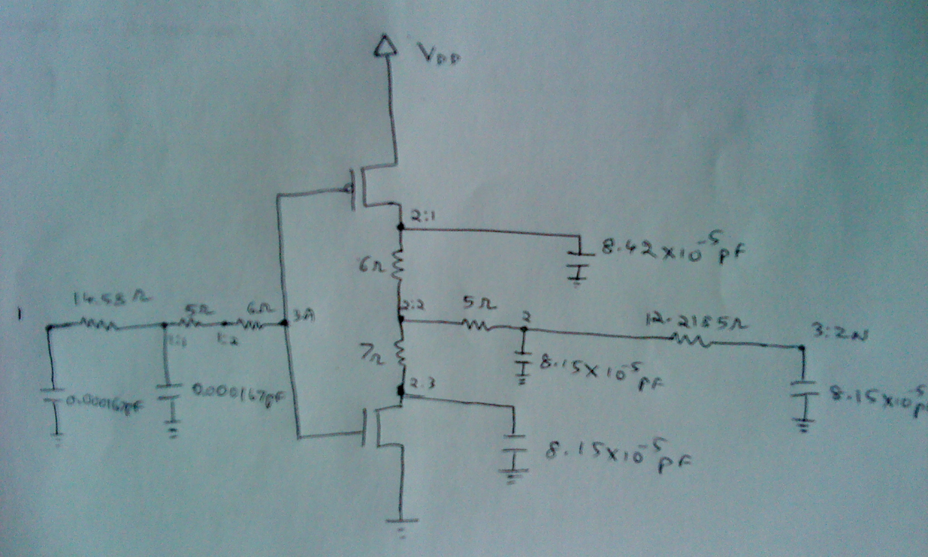
With this as the basis, rename the nodes with simple numbers, write a design in hspice- .sp file
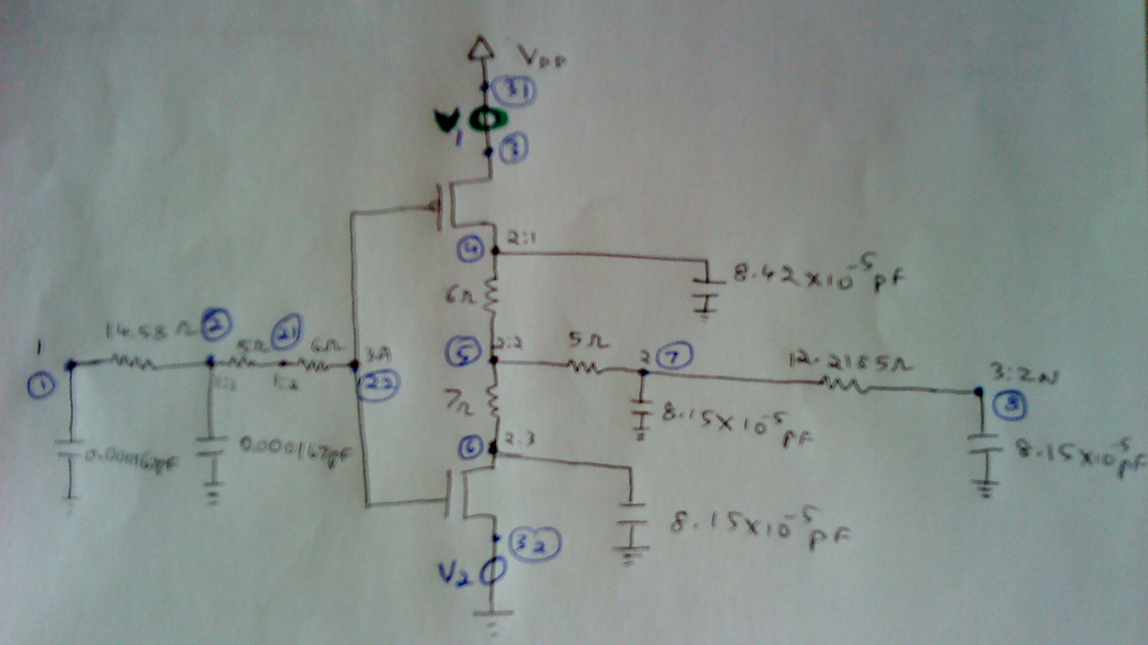
inverter netlist
vdd 31 0 dc 5v
*DC_value PEAK_value delay risetime falltime pulse_width period
Vin 1 0 pulse(5 1m 0 1n 1n 50u 100u)
v1 31 3 dc 0v
v2 32 0 dc 0v
r1 1 2 14.58
c1 1 0 0.000161pF
c2 2 0 0.000161pF
r4 5 7 5
r11 2 21 5
r12 21 22 6
c5 7 0 0.0000815pF
r5 7 8 12.2185
c6 8 0 0.0000815pF
XINV 22 5 3 32 INVERT
*
.MODEL CMOSN NMOS (
+VERSION = 3.1 LEVEL=49 TNOM = 27 TOX = 3.1E-9
+XJ = 1E-7 NCH = 2.3549E17 VTH0 = 0.0485675
+K1 = 0.3634695 K2 = -0.0277136 K3 = 1E-3
+K3B = 3.9409342 W0 = 1E-7 NLX = 8.900764E-7
+DVT0W = 0 DVT1W = 0 DVT2W = 0
+DVT0 = 1.2979753 DVT1 = 0.1605369 DVT2 = 0.2509178
+U0 = 436.2279588 UA = -3.51975E-10 UB = 3.216114E-18
+UC = 4.919099E-10 VSAT = 1.930256E5 A0 = 1.9922632
+AGS = 0.7096599 B0 = 1.892162E-6 B1 = 5E-6
+KETA = 0.05 A1 = 7.799989E-4 A2 = 0.3
+RDSW = 150 PRWG = 0.3506787 PRWB = 0.1097886
+WR = 1 WINT = 7.71429E-9 LINT = 1.039368E-8
+DWG = 1.205322E-8 DWB = 8.815731E-9 VOFF = -0.0331648
+NFACTOR = 2.5 CIT = 0 CDSC = 2.4E-4
+CDSCD = 0 CDSCB = 0 ETA0 = 2.754257E-6
+ETAB = -0.0108095 DSUB = 4.0643E-6 PCLM = 1.9769478
+PDIBLC1 = 0.9710894 PDIBLC2 = 0.01 PDIBLCB = 0.1
+DROUT = 0.9993653 PSCBE1 = 7.973288E10 PSCBE2 = 5.02618E-10
+PVAG = 0.536394 DELTA = 0.01 RSH = 6.7
+MOBMOD = 1 PRT = 0 UTE = -1.5
+KT1 = -0.11 KT1L = 0 KT2 = 0.022
+UA1 = 4.31E-9 UB1 = -7.61E-18 UC1 = -5.6E-11
+AT = 3.3E4 WL = 0 WLN = 1
+WW = 0 WWN = 1 WWL = 0
+LL = 0 LLN = 1 LW = 0
+LWN = 1 LWL = 0 CAPMOD = 2
+XPART = 0.5 CGDO = 3.74E-10 CGSO = 3.74E-10
+CGBO = 1E-12 CJ = 9.581316E-4 PB = 0.9759771
+MJ = 0.404514 CJSW = 1E-10 PBSW = 0.8002028
+MJSW = 0.6 CJSWG = 3.3E-10 PBSWG = 0.8002028
+MJSWG = 0.6 CF = 0 PVTH0 = 2.009264E-4
+PRDSW = 0 PK2 = 1.30501E-3 WKETA = 7.565815E-3
+LKETA = 0.0327047 PU0 = 4.4729531 PUA = 1.66833E-11
+PUB = 0 PVSAT = 653.2294237 PETA0 = 1E-4
+PKETA = -0.0101124 )
.MODEL CMOSP PMOS (
+VERSION = 3.1 LEVEL=49 TNOM = 27 TOX = 3.1E-9
+XJ = 1E-7 NCH = 4.1589E17 VTH0 = -0.2156906
+K1 = 0.2680989 K2 = 4.539197E-3 K3 = 0.097375
+K3B = 6.5043674 W0 = 1E-6 NLX = 2.836757E-7
+DVT0W = 0 DVT1W = 0 DVT2W = 0
+DVT0 = 0 DVT1 = 1 DVT2 = 0.1
+U0 = 106.670318 UA = 1.152986E-9 UB = 2.377339E-21
+UC = -1.93766E-11 VSAT = 1.190739E5 A0 = 1.7356069
+AGS = 0.6166218 B0 = 7.467707E-6 B1 = 4.992767E-6
+KETA = 0.0157125 A1 = 8.723417E-3 A2 = 0.8713799
+RDSW = 105 PRWG = -0.5 PRWB = 0.5
+WR = 1 WINT = 0 LINT = 1.495916E-8
+DWG = 6.058254E-9 DWB = -1.83713E-8 VOFF = -0.1022829
+NFACTOR = 1.5332272 CIT = 0 CDSC = 2.4E-4
+CDSCD = 0 CDSCB = 0 ETA0 = 0.0110506
+ETAB = -2.941775E-3 DSUB = 2.419246E-3 PCLM = 0.2085802
+PDIBLC1 = 9.972716E-4 PDIBLC2 = -1.39497E-13 PDIBLCB = -1E-3
+DROUT = 0.6860806 PSCBE1 = 1.849353E9 PSCBE2 = 5.675435E-10
+PVAG = 0.0149584 DELTA = 0.01 RSH = 6.6
+MOBMOD = 1 PRT = 0 UTE = -1.5
+KT1 = -0.11 KT1L = 0 KT2 = 0.022
+UA1 = 4.31E-9 UB1 = -7.61E-18 UC1 = -5.6E-11
+AT = 3.3E4 WL = 0 WLN = 1
+WW = 0 WWN = 1 WWL = 0
+LL = 0 LLN = 1 LW = 0
+LWN = 1 LWL = 0 CAPMOD = 2
+XPART = 0.5 CGDO = 3.42E-10 CGSO = 3.42E-10
+CGBO = 1E-12 CJ = 1.15643E-3 PB = 0.8
+MJ = 0.4399866 CJSW = 1.133806E-10 PBSW = 0.8
+MJSW = 0.1146401 CJSWG = 4.22E-10 PBSWG = 0.8
+MJSWG = 0.1146401 CF = 0 PVTH0 = 1.282832E-3
+PRDSW = 44.1361752 PK2 = 2.459655E-3 WKETA = 0.0352131
+LKETA = 0.0128331 PU0 = -1.2608844 PUA = -4.27994E-11
+PUB = 1.628153E-28 PVSAT = -50 PETA0 = 7.039749E-5
+PKETA = -5.052402E-3 )
.SUBCKT INVERT 1 2 3 32
mp1 4 1 3 3 cmosp W=0.480000U l=0.13u
+AS=0.0384p AD=0.0384P PD=1.12U PS=1.12U
mn1 6 1 32 0 cmosn W=0.16U L=0.13U
+AS=0.0128P AD=0.0128P PD=0.48U PS=0.48U
r2 4 2 6
r3 2 6 7
c3 4 0 0.0000842pF
c4 6 0 0.0000815pF
.ENDS
.OP
.tran .1u 200u 0
*switching energy pmos
.meas tran switch_qp integ I(v1) from=121ns to=240ns
.meas tran switch_energyp param='5*switch_qp'
*switching energy nmos
.meas tran switch_qn integ I(v2) from=121ns to=240ns
.meas tran switch_energyn param='5*switch_qn'
*avg leakage current
.meas tran leak_I avg I(v1) from=1ns to=600ns
*leakage energy
.meas tran leak_q integ I(v1) from=121ns to=240ns
.meas tran leakage_energy param='5*leak_q'
*leakage power
.meas tran leak_power param='5*leak_I'
.print v1
.PROBE
.END
To run hspice, type hpice on the terminal and give the path of the .sp file.
Leakge power and Switching power measured in the critical path will be shown in the .mto file generated after running hpice, shown below:

$DATA1 SOURCE='HSPICE' VERSION='D-2010.03 32-BIT'
.TITLE 'inverter netlist'
switch_qp switch_energyp switch_qn switch_energyn
leak_i leak_q leakage_energy leak_power
temper alter#
4.198e-15 2.099e-14 5.038e-17 2.519e-16
-9.005e-09 4.198e-15 2.099e-14 -4.502e-08
25.0000 1.0000

